**Overview:** Ethereum Dapp built to track items through Supply chain.

**Program version number:**

* Truffle v5.2.4 (core: 5.2.4)
* Solidity - 0.4.24 (solc-js)
* Node v12.0.0
* Web3.js v1.2.9

**Libraries:**

* **@truffle/hdwallet-provider: "^1.0.18",**
* **dotenv: "^8.2.0"**

**IPFS:**

**UML documents (In the github repo also):**

* **Activity**

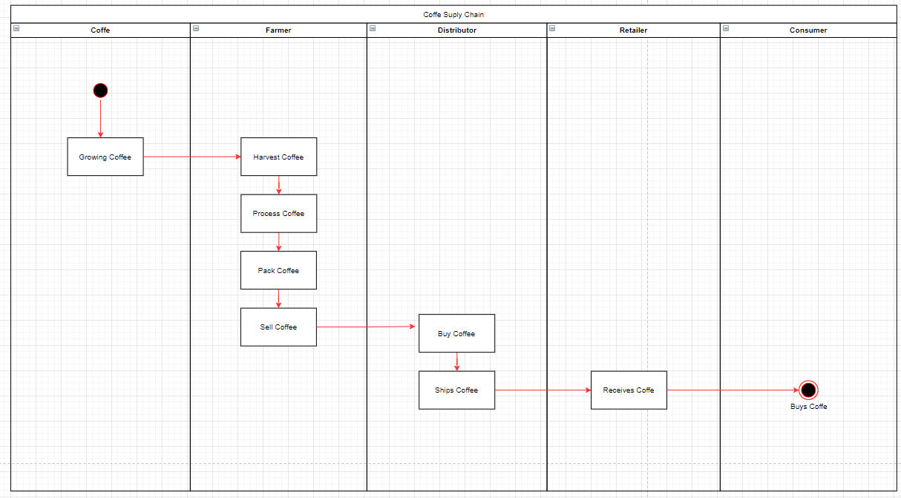

* **Sequence**

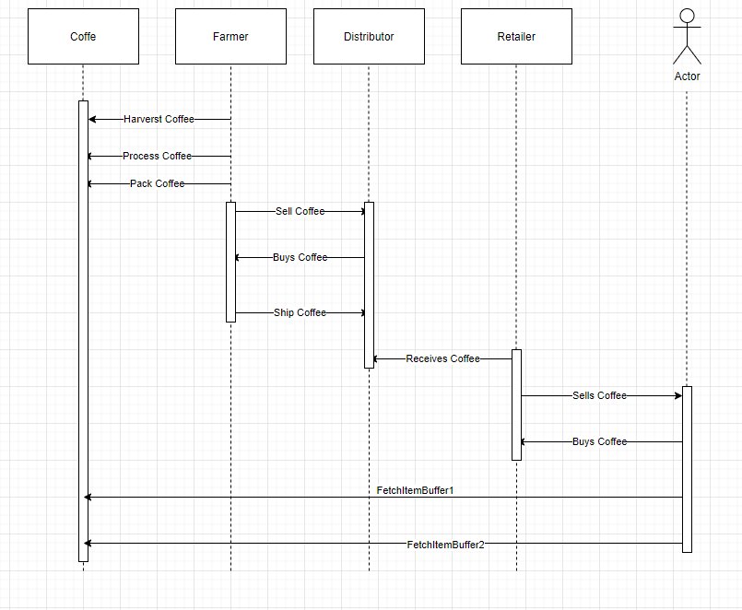

* **State**

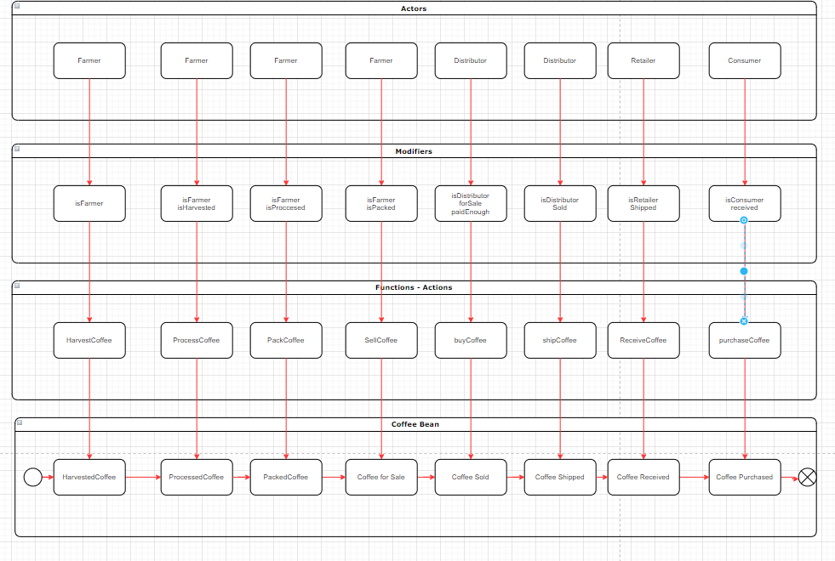

* **Class (Data Model)**

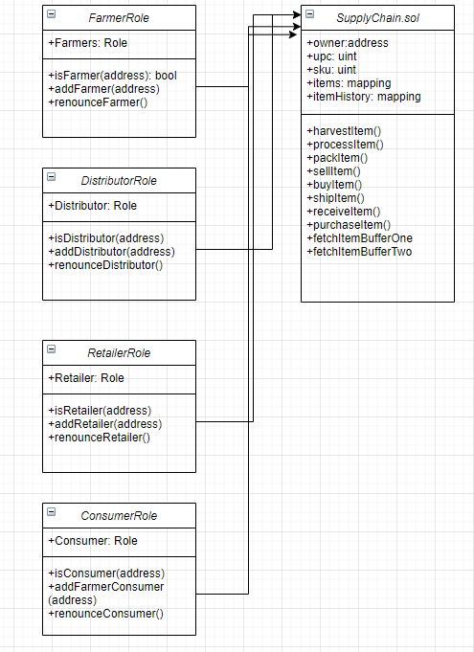

**Contract Address:**

* **FarmerRole:** 0xf8ed684cc7c460cd69bdfdb751b6c3ef50df2bbe
* **RetailerRole**: 0x72bcc2b89f30a4390fe3e61cabf36896ea19bf19
* **ConsumerRole**: 0xb2d1629c2aa923eeb3fce46e05be77eb9d2df1fc
* **SupplyChain**: 0x07cda40ba7b0b8c752cf5894dc221bd4b8e3220f

**Project Images:**

1. Able to successfully compile all of the contracts:

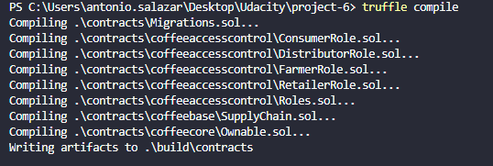

1. All tests have passed

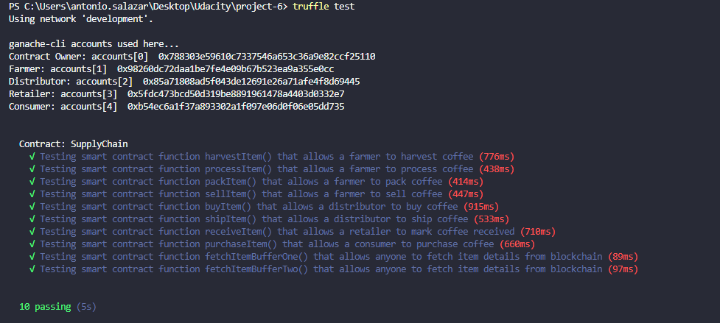

1. Contracts have been successfully deployed to Rinkeby Network

